**Part A: Research**

1. What are Euglena? [1]

**Single-celled organisms / Kingdom Protista / Protists**

1. Both Euglena and sperm swim using a flagellum. Describe in detail how flagella work? [3]

**An arrangement of 9 pairs of microtubules surrounding a central pair. The outer pairs are connected by dynein arms**

**The dynein arms force the microtubule pairs to slide against each other, which causes the flagellum to bend**

**This process requires ATP**

1. Identify an optimum pH range for sperm and Euglena. [2]

**Euglena: between 4 and 8**

**Sperm: between 6 and 8 (semen slightly alkaline / vagina acidic / neutralisation effect makes sperm more motile)**

1. Discuss three factors that affect sperm motility. [3]

**pH / Temperature / mutations (e.g. two heads, two flagella) / viscosity of fluid in vagina, cervix, etc. / or any other reasonable factors**

**Must describe likely effect or -1 mark**

1. Why is sperm motility important? [2]

**To ensure fertilisation**

**Both sperm and eggs are only viable for a short period of time therefore the sperm need to swim as quickly as possible**

1. Construct a table comparing and contrasting the characteristics of sperm and Euglena. Use the following headings: nucleus, specialised organelles/structures, location of flagellum, method(s) for obtaining nutrients [4]

|  |  |  |
| --- | --- | --- |
| **Nucleus** | **Contains a true nucleus (diploid)** | **Pro nucleus (23 chromosomes)** |
| **Specialised organelles/structures** | **Contractile vesicle to remove water and prevent osmotic damage to the cell / Contains a light sensitive ‘eye spot’ to swim towards light** | **Acrosomal sac for penetrating the layers surrounding the egg** |
| **Location of flagellum** | **Flagellum at front, pulls organism through water** | **Flagellum at back, pushes sperm forward** |
| **Method(s) for obtaining nutrients** | **Capable of photosynthesis as well as nutrient absorption** | **Relies on nutrients contained in semen** |

**Part B: Practical**

1. Present all of your results in a table. [5]

**Average percentage of motile Euglena in various pH solutions**

|  |  |  |  |
| --- | --- | --- | --- |
| **pH** | **Time** | | |
| **0 minutes** | **5 minutes** | **15 minutes** |
| **4.0** |  |  |  |
| **4.5** |  |  |  |
| **5.0** |  |  |  |
| **5.5** |  |  |  |
| **6.0** |  |  |  |

**Title [1] / Headings [2] / Data [2]**

1. Identify the independent and dependent variables. [2]

**Independent: pH / Dependent: percentage of motile Euglena**

1. List four control variables in this investigation and explain why it was necessary to control each one. [4]

**Volume of fluids used / Magnification / Field of View / Time of observations / Avoiding cross contamination of pH solutions / Euglena culture / etc**

**Must include explanation for each control**

1. Write a suitable hypothesis for this investigation. [2]

**Any suitable hypothesis linking pH to motility**

1. What conclusions can you draw from this investigation? Include in your answer a reason as to why pH might affect the efficiency of a flagellum [4]

**pH outside optimal range decreases motility**

**Longer exposure times decrease motility further**

**pH affects enzyme activity**

**which in turn affects the energy supply to the flagellum**

1. This investigation aims to simulate sperm motility using live Euglena. Based on your research of sperm and Euglena, would you expect similar results if you had conducted this experiment using sperm? Explain your answer. [3]

**Both have flagella, so both should show reduce motility outside their optimal pH range**

**The optimal pH range for sperm is narrower than that of Euglena / sperm are more sensitive to pH**

**Sperm might not show motility at the pH range used in this experiment**

**Part C: Validation Assessment**

**Factors affecting the motility of Euglena**

1. Why was it critical to use separate pipettes for each pH solution during your investigation into the effect of pH on Euglena motility? [1]

**To prevent cross-contamination of solutions**

**To ensure that the solution on the slide was at the correct pH**

1. During the investigation you estimated the percentage of motile Euglena in five different fields of view for each pH solution. If you had digital photographs of each these fields of view, how could you use this information to improve the accuracy of your results? [1]

**An exact count of Euglena could be made and thus a more accurate percentage calculated**

1. The diagram below shows a cross-section of a flagellum as viewed through an electron microscope. Use this diagram to help answers parts (a) and (b).

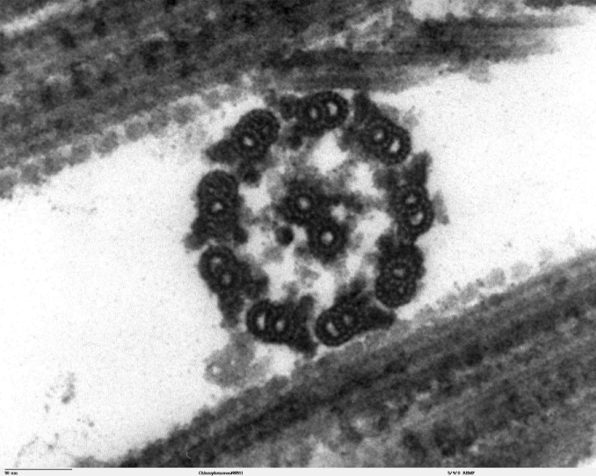

A

1. Name the structure label A. [1]

**Microtubule**

1. If the scale bar in the bottom left corner represents 50 nanometres, what is the diameter of the flagellum? Use the double headed arrow as a guide to the diameter. [1]

**190-210 nm**

1. How does the location of the flagellum differ between a Euglena and a sperm?

**Euglena have a flagellum at the front, sperm at the back**

1. The following text describes another investigation into factors affecting the motility of Euglena. Use this information to help answers parts (a) to (e).

*Euglena were placed in solutions at various temperatures ranging from 10 to 42oC. After allowing 10 minutes for the Euglena to acclimatize to the solution, samples were placed onto slides for viewing under a microscope. Slides were viewed at 400x magnification and then two digital photographs were taken. The photographs were taken exactly 5 seconds apart using an electronic timer. By measuring the distance selected Euglena had travelled between the first and second photographs, their speed was calculated.*

The images below represent two of the photographs that were taken during the investigation for a solution at 18oC.

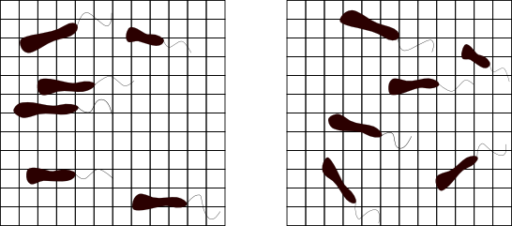

First Image (Time = 0 seconds)

Second Image (Time = 5 seconds)

**A**

**A**

**B**

**B**

**C**

**C**

Each square is 5 micrometres wide

1. Using the information in the images, calculate the speed of Euglena B. [1] Note the formula for calculating speed is distance (micrometres) divided by time (seconds).

**V = d/t**

**17.5/5 = 3.5 µm/s**

1. A critical assumption of this experiment is that the selected Euglena travelled in a straight line between the two photographs. Is this a reasonable assumption for the Euglena B? Explain your answer. [1]

**Yes, appears to have travelled in a straight line parallel to the grid**

The table below shows the final results for the investigation.

|  |  |
| --- | --- |
| Temperature (oC) | Average speed (micrometres per second) |
| 10 | 2.97 |
| 18 | 3.61 |
| 26 | 3.50 |
| 34 | 3.47 |
| 42 | 3.12 |

1. Based on your calculation is the speed of Euglena B above or below average? [1]

**(Slightly) Below average (3.5 < 3.61, the average speed at 18oC)**

1. What is the independent variable in this experiment? [1]

**Temperature**

1. What conclusions can be drawn from this experiment? [2]

**Temperature affects the speed of Euglena**

**Speed significantly decreases at 10 and 42oC**

**There is little change in speed between 18 and 34oC**

**Any two points, 1 mark each**

1. Describe why flagella are affected by temperatures or pH outside the optimum. [2]

**Flagella rely on energy created using reactions catalysed by enzymes**

**The activity of enzymes decrease when outside optimum pH and temperature ranges**

1. Sperm generally die when exposed directly to vaginal fluid, however when semen mixes with vaginal fluid, the sperm swim better than in semen only. Explain why sperm swim best, a state called hypermotility, when in a mixture of semen and vaginal fluid. [2]

**Neither semen (too alkaline) nor vaginal fluid (too acidic) is at the optimum pH for the enzymes**

**driving the sperms’ flagella**

**When mixed together the optimum pH is achieved**